<THIS SECTION HAS TO COME AFTER METHODOLOGY and replaces what it there>

For the simulation depicted in Figure 2, the .csv files used are “FiftyAgents.csv” and “VLfive.csv”, also found in the directory /data in the github repository. The Hazard Radius was set prior to the run (see Handbook) to 15, and the MingleFactor left unchanged at 10, with an initial set of five transmitters. This value will generally produce a rapidly spreading infection that will affect all or almost all persons within a given space. In other words, when HazardRadius is set at this value in CovidSIMVL, herd immunity is typically not achieved until essentially all Susceptibles have been infected. Lower levels will increase the likelihood of a larger fraction of the initial Susceptible population being uninfected by the time the infection extinguishes.

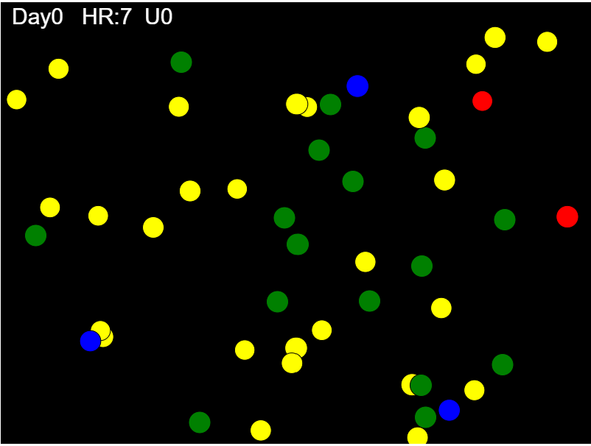

Figure 2. Single Universe Simulation, 65% infected after 7 iterations

METHODOLOGY

CovidSIMVL is an open source public domain system freely available under the GNU Open License Framework, and can be found at [www.github.com/ecsendmail/MultiverseContagion](http://www.github.com/ecsendmail/MultiverseContagion). It is written in Javascript and runs in most modern browsers such as Chrome, Edge, Safari and Firefox.

The repository named above contains the Handbook in the directory /docs, which contains step by step instructions for running CovidSIMVL on the browser. For the trials in this article, the two .csv files, “population.csv” and “VL1.csv”, found in the directory /data, need to be cloned or copied to the user’s local directory.

The demonstration run for Figure 2, showing the different viral states as reflected by agent color, was created by using the files “FiftyAgents.csv” and “VLfive.csv” also in the /data directory.

The R0 trials were performed by using a population of 100 identical agents, with a single initial transmitter, and Hazard Radius and MingleFactors set as per the Table 1. The trials were run either till 50% of the agents were still surviving (Green) or the trial self-extinguished. At that point, the R0 value was recorded. The CovidSIMVL simulation has the capacity to record every single transmission that a transmitter succeeds in till it becomes inert (from Red symptomatic to Orange inert), about 10 days after onset of symptoms. Therefore at the end of the trial, the total number of transmissions by the inerts, averaged, is the estimate of R0. The .csv files used for these trials were “HundredAgents.csv” and “VL1.csv” found in /data directory in the repository.

The results for calculating Risk per Hour and for the derivation of Transmission Trees are based on the ability of modern browsers to have a console.log, into which CovidSIMVL reported each transmission of the virus from a named Agent to a Named agent at the time (generation) in which the transmission occurred. This time series forms the basis of the calculations of RPH and Transmission Trees.

For the data in Table 2, the Hazard Radius was its default value of 5, and the same “HundredAgents.csv” and “VL1.csv” files were used, with MingleFactors set by the user at run time as shown. These data produced the graph in Figure 4, although the data for MingleFactor 30 was not included in the Table2.

Figure 5 was created with the run-time Hazard Ratio changed to 4, and the other parameters as described in the preceding paragraph. The data table forming the basis of Figure 5 is not included for economy.

CAVEAT: CovidSIMVL is a simulation program based on stochastic Monte-Carlo probabilistic generations of agent moves and viral dynamics in each generation. In particular, the positioning of agents determine the sequences of transmissions. This will differ from one trial to the next, and the reader is warned that the exact results cannot be duplicated as they might be in a deterministic simulation.

Indeed, the probabilistic nature of the unfolding of events in a Monte Carlo set of simulations reflect an inherent imbalance between the Law of Large Numbers, which state that the average of many many trials will produce the true mean value of the system metric, and the fact that a particular reality is always THE only reality that we have, and there is no real way of knowing whether this reality is an outlier, or close to the mean.

An R interface to the simulation engine in CovidSIMVL has been developed in order to run the simulations many times over. This does not reduce the CAVEAT above, nor make any particular outcome of a trial less valid than another.

ERRATA: The various changes in an evolving system (CovidSIMVL) means that the current version on github.com/ecsendmail/MultiverseContagion may have a parameter setting for MingleFactor which differs from this paper by an order of magnitude. What is shown in the Tables as 1.10 may need to be entered as 11 in newer versions of CovidSIMVL.